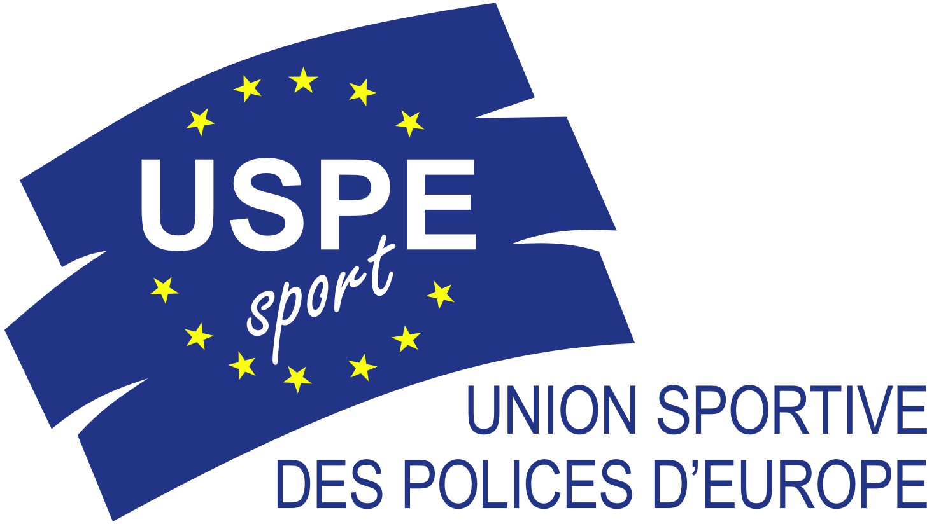 |  | 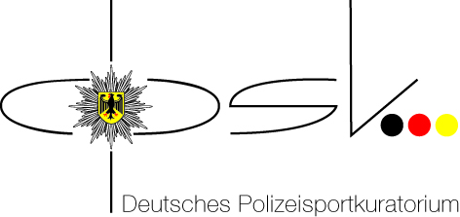
Berlin, 27.01.2012

14th European Police Championship in Handball Men

19th – 25th June 2012 in Goppingen/Germany

Invitation to Enter

The German Police Sports Association (DPSK) was entrusted by the Union Sportive des Polices d’Europe (USPE) with the organization of the 14th European Police Championship in Handball Men.

1. General organizer
Union Sportive des Polices d’Europe (USPE)

2. Organizer

Deutsches Polizeisportkuratorium (DPSK)

Organizing committee:
Riot Police Directorate Göppingen
Organizing committee EPC Handball
Heininger Str. 100
73037 Göppingen

Tel.: +49 7161 616-2800
Fax.: +49 7161 616-2620
E-Mail: GOEPPINGEN.BPD.EPM@polizei.bwl.de

Internet: www.epm-handball.de

3. Date

Arrival: 19.06.2012
Departure: 25.06.2012

4. Venue

Riot Police Directorate Göppingen (opening ceremony)
Heininger Strasse 100
73037 Göppingen
Tel.Nr.: +49 7161 616-2800
Fax: +49 7161 616-2620
Group game, Semi- Finals and placement games 5-8
Voralbhalle Heiningen
Krautgarten 3
73092 Heiningen
Tel.: +49 7161 40917

Final, match for place 3, closing ceremony)
EWS Arena Göppingen
Nördliche Ringstraße 87
73033 Göppingen
Tel.: +49 7161 956480

5. Accommodation

Seminaris Hotel Bad Boll
Michael-Hörauf-Weg 2
73087 Bad Boll
Tel.: +49 (0) 7164 805-0
Fax: +49 (0) 7164 805-551
www.seminaris.de/hotels/seminaris-hotel-bad-boll.html

Travel information
Transport will be provided from Stuttgart airport and Göppingen main station.

Delegations which need a VISA are requested to contact the host in time.

6. Referees

For the European Police Championship the following referees have confirmed their participation:

Jens Carl Nielsen Denmark
Anders Birch Nielsen Denmark
Mark De Moor Belgium
Luc Uten Belgium
The European Handball Federation (EHF) was asked to send two couples of referees. It is also planned by the organizing committee to provide one couple of referees from the Handball Federation of Baden- Württemberg.

7. Classification

Preliminary Round/Qualification for the Final Round

The USPE Technical Commission has decided about the mode of qualification at their meeting from 16th – 17th of September 2011 in Monaco:

10 member nations announced their participation for the EPC Handball Men 2012. According to the Competition Rules the organizer Germany, is directly qualified.
Germany also was the winner of EPC 2008. Also France (no.3), Sweden (no.4), Denmark (no.5) and Hungary (no.7) took part in the Final Round of the USPE EPC Handball Men 2008 and are directly qualified.

In the Preliminary Round for the EPC 2008 Norway played away and Switzerland played home. One of these two teams is – by drawing – directly qualified.

The drawing among the remaining teams: Austria, Luxembourg, Turkey and Norway / Switzerland.
The drawing ends up with 2 preliminary matches.
The winners of the matches are qualified for the Final Round in Germany.

If Norway is drawn to play the Preliminary Round, Norway should play home, because the team played away in 2008. If Switzerland is drawn to play the Preliminary Round, Switzerland should be play away, because the team played at home 2008.

Draw for the direct qualification for the Final Round 2012 resulted:

Norway

Norway is directly qualified for the Final Round.

Draw for the Preliminary Round:
Teams: Austria, Luxemburg, Switzerland, Turkey,

Game 1 |  |  | USPE Technical Delegate for the Match
Turkey | vs. | Luxemburg | Ivar Thoresen
Game 2
Austria | vs. | Switzerland | Fred Kusserow

Game 1 29.02.2012 in Ankara/ Turkey
Game 2 20.03.2012 in Bärnbach/ Austria

Final Round
The EPC will play in two groups with 4 teams. Each team will play against the other teams in the groups. After the matches in the groups the teams will play crossover for the Semi-Finals and the placement games.

The draw for the groups will take place on 24th April 2012 at 11.00 h in the EHF Headquarter in Vienna.

8. Timetable

Group game, 20.06. - 22.06.2012
Timeframe | Venue | Group game | Gamefixture
Wednesday, 20.06.2012
12:00 - 13:30 | Voralbhalle | Group A | Gr A: A 1 - A 3
Warm up |  |  | Break
14:30 - 16:00 | Voralbhalle | Group B | Gr. B: B 1 - B 3
Warm up |  |  | Break
17:00 - 18:30 | Voralbhalle | Group A | Gr A: A 2 - A 4
Warm up |  |  | Break
19:30 - 21.00 | Voralbhalle | Group B | Gr. B: B 2 - B 4
Thursday, 21.06.2012
12:00 - 13:30 | Voralbhalle | Group A | Gr A: A 2 - A 3
Warm up |  |  | Break
14:30 - 16:00 | Voralbhalle | Group B | Gr. B: B 2 - B 3
Warm up |  |  | Break
17:00 - 18:30 | Voralbhalle | Group A | Gr A: A 1 - A 4
Warm up |  |  | Break
19:30 - 21.00 | Voralbhalle | Group B | Gr. B: B 1 - B 4
Friday, 22.06.2012
12:00 - 13:30 | Voralbhalle | Group A | Gr A: A 3 - A 4
Warm up |  |  | Break
14:30 - 16:00 | Voralbhalle | Group B | Gr. B: B 3 - B 4
Warm up |  |  | Break
17:00 - 18:30 | Voralbhalle | Group A | Gr A: A 1 - A 2
Warm up |  |  | Break
19:30 - 21.00 | Voralbhalle | Group B | Gr. B: B 1 - B 2
Semi-Finale a. Placement game - Saturday, 23.06.2012
 |  | Semi-Final – Placement game
10:00 - 12:00 | Voralbhalle | Match for place 7 | 4. Gr. A - 4 Gr. B
Warm up |  |  | Break
13:00 - 15:00 | Voralbhalle | Match for place 5 | 3. Gr. A - 3 Gr. B
Warm up |  |  | Break
16:00 - 18:00 | Voralbhalle | 1. Semi-Final | 1. Gr. A - 2. Gr. B
Warm up |  |  | Break
19:00 - 21.00 | Voralbhalle | 2. Semi-Final | 1. Gr. B - 2. Gr. A
Finalday - Sunday, 24.06.2012
Warm up |  |  | Break
12:00 - 14:00 | EWS-Arena | Match for place 3 | Loser SF 1 - Loser SF 2
Warm up |  |  | Break
16:00 - 18:00 | EWS-Arena | Final | Winner SF 1 - Winner SF 2

9. Competition rules

The organizer has to ensure that a medical first aid will be present at every match.

The organizer also has to make sure to meet the safety requirements.

The USPE Competition Rules, item 4.3, shall apply.

4.3.1 The rules and regulations laid down by the EHF shall apply, unless otherwise stipulated below or provided for in the invitation to enter.

4.3.2 The EPC shall comprise preliminaries and a final round.
Preparation and organisation of the preliminary rounds depend on the number of engaged teams. Subject to rule 1.3.1, at least six teams take part in the final round. The number of participating teams is set by the TC and is determined among other things to the total number of enrolled teams. The team of the organising member union is qualified directly.
Each team may enter up to 14 players and four attendants in the preliminary rounds and up to 16 players and four attendants in the final round.

4.3.3 The Technical Commission determines the organisational framework of the preliminaries and the rules and regulations applicable to the final round.
The preliminaries should be concluded no later than four months prior to the start of the final round.

    - If two or more teams have gained the same number of points from the group matches, the teams will be ranked as follows:
- goal difference in the direct encounter of the teams,
- greater number of plus goals in the direct encounter of the teams,
- goal difference in all matches (achieved by subtraction),
- greater number of plus goals in all matches.
If the rank is still not possible, a draw decides the ranking. The draw shall be carried out by the USPE, if possible in presence of the responsible team officials.

4.3.5 If a placement match, semi-final or final ends in a draw, there shall be a five minutes break followed by an extra time of 2 x 5 minutes, with a 1-minute half-time break.
If the match is still undecided after the first period of extra time, there shall be another break of five minutes followed by a second period of extra time of 2 x 5 minutes, with a 1-minute half-time break.
If there is no winner after the second period of extra time, the match will be decided by penalty throws.

10. Jury of appeal

1. KD a. D. Wolfgang Vöhringer Handball Federation Württemberg
2. PHK Holger Böttcher Schleswig - Holstein
3. EPHK Claus Hering Head of handball of the police of Baden-Württemberg
4. Ivar Thoresen Member of the USPE Technical-Commission
5. Fred Kusserow Secretary General

All appeals have to be made in writing by the delegate of the member union in question within less than an hour after the end of the fixing or of the publication of the results.
The protest must be written in one of the three official languages of the USPE.
The protest fee will be a total of 100,00 EUR, paid in cash.

11. Eligibility to start

Article 23 Statutes: The Competitors

(1) Participation in Championships is restricted to athletes who:
1. meet the starting requirements of their International Union,
2. belong to a National sport’s organisation that is a member of USPE,
3. are police officers or
4. are police students at a public Police Academy,
5. have reached the age of 18 years at the of the Championship
6. and have signed the Anti-Doping Declaration.

Article R 12/2 of the Rules and Regulations: Competitors

(1) In order to be able to take part in an European championship organised by the USPE, the members of the member unions have to fulfil the following conditions:
1. They have to satisfy the provisions set out in Article 23 of the Statutes.
2. They have to be police officers or students at a public police academy. The police are a set of all bodies and institutions in charge of maintenance of public law and order (administrative police and crime investigation departments).

(2) Military police, members of the military, members of the fire brigades and civil servants that do not belong to the police are excluded from European police championships.

Sub-paragraph 1.5 of the Competition Rules
Sportsmen and sportswomen having participated in military championships are not eligible to enter European police championship for 12 months following these military championships.

Sub-paragraph 1.8 of the Competition Rules
Competitors suspended from sports contests by the respective sports association due to having violated the relevant doping regulations are not eligible to enter.

Sub-paragraph 1.9 of the Competition Rules
All teams shall wear uniform sportswear displaying the emblems of their individual member union.

The provisions laid down in the Statutes, the Rules and Regulations, the Competition Rules as well as the Anti-Doping Regulations of the USPE shall apply.

12. Verification of eligibility to enter

For verifying a contestant’s eligibility to start, the production of his/her police ID, his/her passport/personal identity card as well the signed Anti-Doping-Declaration will be required.
All participating countries have to bring the USPE Declaration of Participation for each athlete who will participate, signed by the respective President or Secretary General.

The verification will be effected by the representative of the Technical Commission,
Mr. Ivar Thoresen.

13. Anti Doping

Doping tests will be conducted during the championship, with the current WADA list of prohibited substances being applicable. (www.wada-ama.org).
Every competitor must sign the USPE Anti-Doping-Declaration and hand it over to the USPE Technical Delegate at the accreditation.

14. Expenses/fees

14.1 Travelling expenses

Each member union will defray its own travelling expenses.

14.2 Board and lodging

Delegate
The expenses incurred by the delegate (Article R 11 of the Rules and Regulations) of the respective member union will be paid by the organizer.

Team
For all participants 30,00 EUR per person per night are to be paid to the organizer (Article R 14/3 of the Rules and Regulations).

Guests
Should a member union intend to take guests with them to the USPE European Police Championship Handball Men 2012 and should the organiser be able to provide the respective accommodation, each guest shall pay the actual costs incurred by them and charged by the organizer.

Single room/ breakfast: 45,00 EUR
Double bedroom/breakfast per person: 45,00 EUR
Additional lunch and dinner: 50,00 EUR

THK Europäische Polizeimeisterschaft Handball
Kreissparkasse Göppingen
BLZ: 610 500 00
Konto - Nr.: 1255261727
SWIFT: Nummer: GOPS DE 6G
IBAN: DE 13 61050000 1255261727

The respective invoices will be sent by the organizer.

15. Registration fee

Article R 14/2 of the Rules and Regulations:
Prior to a championship each participating nation has to pay a registration fee to the General Treasurer of the USPE.
This fee has to be paid before the opening of the championship.

Registration fees:
Each start (team): 500,00 EUR

The respective invoices will be sent to the participating member countries in time by the USPE.

16. Registration

You are requested to send enclosed forms to:

Deutsches Polizeisportkuratorium  E–mail: info@dpsk.de  E-Mail: GOEPPINGEN.BPD.EPM@polizei.bwl.de | Office of the USPE Secretary General  E–mail : office@uspe.org

Please meet the following deadlines:
Form 2: Registration Form 03.02.2012
Form 3: Participants Names. 08.05.2012
Form 4: Travelling Details 29.05.2012

17. Restriction of personality rights

Entrants consent through their entry that their personal data/information shall be recorded for the generation of entrant, competition and results’ lists in a file and shall be published on the Internet or in USPE publications.
They also consent that photographs/film recordings produced prior to, during and after the event may be used for the purpose of USPE public relations work.

18. Disclaimer

The USPE and the Police Sports Association of Germany (DPSK) shall not assume any liability in the event of accidents, theft and other events of damage or loss.
The disclaimer shall be recognised upon registration for the event.

19. Notes

One contestant per team has to wear the police uniform of their respective country at the opening ceremony.

All teams shall wear uniform sportswear displaying the emblem of their individual member union.

As to the Final Banquet, you are requested to attend adequately dressed to suit the occasion (blue jeans are not welcomed!).

The participating teams are responsible for the assurance of their delegation.

Fred Kusserow Johann Peter Holzner
USPE Secretary General Vorsitzender
Deutsches Polizeisportkuratorium

Appendix: USPE Anti-Doping-Declaration, USPE Declaration of Participation
Anti-Doping
Declaration
I, First Name Name , herewith confirm that I know and acknowledge the USPE Anti-Doping Regulations and the WADA World Anti-Doping Code.

Doping constitutes a violation of the USPE Anti-Doping Regulations.

Violations of Anti-Doping Regulations are:

- The presence of prohibited substances, its metabolites or markers in the athlete’s bodily specimen.

  - It is each athlete’s personal duty to ensure that no prohibited substances enter his or her body. Athletes are responsible for any prohibited substance or its metabolites or markers found to be present in their bodily specimens. Accordingly, it is not necessary that intent or negligence on the athlete’s part be demonstrated in order to establish an anti-doping violation.
  - The presence of any quantity of a prohibited substance or its metabolites or markers in an athlete’s sample shall constitute an anti-doping rule violation, excepting those substances for which a quantitative reporting threshold is specifically identified in the WADA “List of Prohibited Substances and Methods”.
  - As an exception to the general rule, the „WADA List of Prohibited Substances and Methods“ may establish special criteria for the evaluation of prohibited substances that can also be produced by the body itself (endogenously).

- Use or attempted use of a prohibited substance or a prohibited method.

  - The success or failure of the use of a prohibited substance or prohibited method is not material. It is sufficient that the prohibited substance or the prohibited method was used or attempted to be used for an anti-doping rule violation to be committed.
  - Refusing, or failing without compelling justification, to submit to sample collection after notification as authorised in the USPE regulations or any other anti-doping regulations, or otherwise attempting to willingly evade sample collection.
  - Tampering or attempting to tamper with any part of doping control.

- Possession of prohibited substances and prohibited methods.

  - Possession by an athlete
Possession by an athlete at any time or place of substances that are prohibited in out-of-competition testing in accordance with the WADA Prohibited List or the use of prohibited methods by an athlete, unless the athlete establishes that the possession is pursuant to a Therapeutic Use Exemption (TUE) granted or other acceptable justification.
  - Possession by athlete support personnel
Possession by athlete support personnel of substances that are prohibited in out-of-competition testing in accordance with the WADA Prohibited List or the use of prohibited methods by athlete support personnel (in particular doctors, trainers/coaches , attendants and support staff) in connection with an athlete, competition or training, unless the athlete support personnel establishes that the possession is pursuant to a Therapeutic Use Exemption (TUE) granted to the athlete or other acceptable justification.

- Trafficking in any prohibited substance or prohibited method.

- Administration or attempted administration of prohibited substances or prohibited methods to any athlete or assisting, encouraging, aiding, abetting, covering up or any other type of complicity involving an anti-doping violation or any attempted violation of the anti-doping regulations.

- Participation or attempted participation in European Police Championships during a period of suspension or ineligibility imposed by the USPE or any other international or national sports federations.

The undersigned accepts full personal responsibility for compliance with the above set of rules. He/she accepts that any violation of these regulations will give rise to sanctions, in particular with regard to cost of proceedings and the respective measures governed by the applicable national provisions of the member countries.

______________________________ _______________________________
Venue, date Signature Athlete, Attendant, Delegate

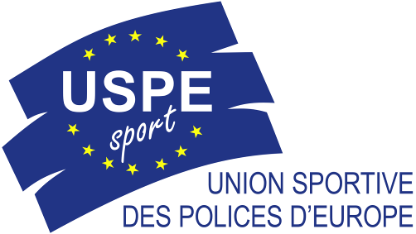 | DECLARATION OF PARTICIPATION  IN A EUROPEAN POLICE CHAMPIONSHIP (USPE)
In application of the decision adopted by the USPE Congress in Antwerp (Belgium) on 23 October 2010 and of the provisions contained in the USPE Statutes as well as the USPE Rules and Regulations,

I, the undersigned,

Last name: ………….....................................................First name: …………………………….

 President  Secretary-General

of the following association (federation) : ...........................……………………………………………………
…………………………………………………………………………………………………...................................................................................................................................................................

- hereby declare that the following competitor,

Last name: ……………………………………………...First name: …………………………….

Date of birth: ………………………Gender:  M  F Nationality: ……………..……..

complies with the following conditions of participation in a European Police Championship (EPC); he/she

- satisfies the relevant entry conditions established by the International Federation,
- belongs to a national organization that is a member of the USPE,
- is a member of the police profession and works actively in law enforcement to ensure the security of property and persons or the maintenance of public order, or, failing that, is a trainee at a police school and in line to become a member of the police profession,
- will be at least 18 years old by the first day of the European Police Championship in question,
- must sign the USPE anti-doping declaration,
- will be able to present to the USPE technical delegate a police ID as well as a further identification document, both of which are valid,
- is not a member of a military police unit, a military unit, or a firefighting unit,
- is not a member of a civilian profession,
- has not participated in a military competition in the 12 months preceding the European Police Championship,
- is not under disciplinary sanctions for violation of anti-doping rules;

- the competitor is aware that these conditions apply to the final phase just as much as they do to the preliminary phase of the European Police Championship;
- I undertake to deliver this declaration of participation or to have it delivered to the USPE technical delegate or USPE official observer during accreditation at the European Police Championship or Preliminary Round of an EPC.

Place: Date:
Seal and signature:

