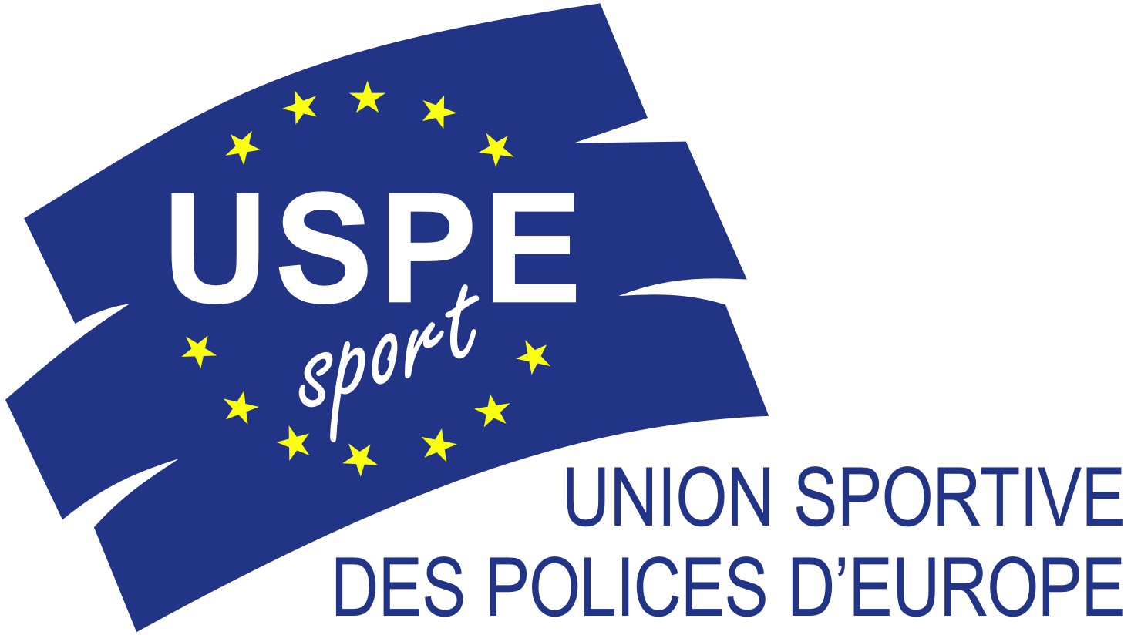
Berlin, 24th November 2014

USPE European Police Championship Volleyball Women 2015

Preliminary Round

Invitation to Enter

The Sport Federation of Russian Militia (SFRM) was entrusted by the Union Sportive des Polices d’Europe (USPE) with the organization of the 3rd USPE European Police Championship Volleyball Women from 5th – 11th October 2015 in Sankt Petersburg.
The following invitation to enter is issued for the Preliminary Round of the USPE EPC Volleyball Women 2015.

1. General organizer
Union Sportive des Polices d’Europe (USPE)

2. Classification/Organizer/Groups:
12 member nations announced their participation:
Austria, Czech Republic, Denmark, Finland, France, Germany, Greece, Norway, Poland, Russia, Slovak Republic, United Kingdom

As host Russia is directly qualified for the final round according to the USPE Competition Rules.

The USPE Technical Commission decided to have the qualification as follows:

Czech Republic and Germany are directly qualified.

Group A: Finland
No organizer Slovak Republic
at the moment Denmark

Group B: (A) United Kingdom (Organizer)
(B) Austria
(C) Poland

Group C: (A) Greece (Organizer)
(B) France
(C) Norway

Qualification for the Final Round:
The 1st of each Preliminary Group and the two best 2nd teams compared of all Groups are qualified for the Final Round.

Classification in each Group:
- Match points
Match won (3-0 or 3-1) 3 points
Match won (3-2) 2 points
Match lost (2-3) 1 point
match lost (2-3) o point

2. Set quotient

3. Set points quotient

4. The winner of the match opposing the two concerned teams is classified above the looser.

3. Date

The preliminary round has to be played from
1st January 2015 – 30th June 2015.

Planned dates per Group (if already available)

Group A:
No organizer/no date/venue until now

Group B:
United Kingdom/no date/venue until now

Group C:
Greece/no date/venue until now

4. Invitation to Enter
The provisions of the USPE Competition Rules, paragraph 2.3, shall apply.

Each host is requested to send the necessary information to the USPE Office. After that, the Invitation to Enter for each Group will be send to the teams by the USPE Office.

5. Venue

Each host is responsible for the venue. The venue has to fit the provisions of the USPE Competition Rules.
The minimum standards are:
- Height of ceiling: 7 m
- Release postpones 5 m
- Side Release: 3 m

6. Accommodation

The accommodation will be provided by the host of the respective Group.

Travel information
Transport will be provided from the nearest airport/train station by the respective host.

Delegations which need a VISA are requested to contact the host in time.

7. Referees

Each host is in charge of sufficient referees at least of the highest national level.
The minimum number of referees are 4 and 2 for the mark table
If the venue does not have an electronic scoreboard, it is necessary to have two manual scoreboards.
The scores have to be on official FIVB sheets or official sheets of the national Volleyball Federation.

8. Timetable

The organizers are requested to meet one of the frame schedules (A or B)

Schedule A | Schedule B
Day 1  Arrival of the delegations, training, control and accreditation, then technical meeting | Day 1  Arrival of the delegations, training, control and accreditation, then technical meeting
Day 2  9:00 Opening Ceremony  10:30 Match A-C  17:30 Match C-B  Official Dinner | Day 2  12:00 Opening Ceremony  13:30 Match A-C
Day 3  09:30 Match A-B  Departure | Day 3  09:30 Match C-B  16:30 Match A-B  Official Dinner
Day 4
Departure

The USPE Technical Commission decided that there must be a minimum pause of 5 hours between the matches (ending/beginning).

In addition, no match on the arrival day shall be played.

9. Competition rules

The organizer has to ensure that a medical first aid will be present at every match.

The organizer also has to make sure to meet the safety requirements.

The USPE Competition Rules, paragraph 4.4, shall apply.

4.4 Volleyball

4.4.1 The rules and regulations laid down by the Fédération Internationale de Volleyball (FIVB) apply, unless otherwise stipulated below or provided for in the Invitation to Enter.

4.4.2 The EPC shall comprise Preliminary Rounds and a final round.

Preparation and organisation of the Preliminary Rounds depend on the number of engaged teams. Subject to rule 1.3.1, at least six teams take part in the final round. The number of participating teams is set by the USPE Technical Commission and is guided among other things to the total number of enrolled teams. The team of the organising member union is qualified directly.

For the preliminary round, every team will be able to engage a maximum of 12 players and up to three attendants.

For the Final Round, every team will be able to engage a maximum of 12 players and up to four attendants.

The list of the players is closed during the technical meeting. No changes will be allowed after the technical meeting.

The USPE Technical Commission shall determine the organisational framework of the Preliminary Rounds and the rules and regulations applicable to the Final Round eighteen months before the organisation of this last one.

The Preliminary Rounds should be concluded no later than four months prior to the start of the Final Round.

4.4.3 In the event of level scores regarding both the Preliminary Rounds and the Final Round, the final rankings shall be determined in accordance with Art. 4.7 of the “Senior European Championships Regulations” laid own by the Européenne de Volleyball (CEV).

Please note number 4.4.2:

For the Preliminary Round, every team will be able to engage a maximum of 12 players and up to three attendants.

Each team must have at least two sets of shirts of different colours.

The numbers have to be fixed on the chest and on the back.

Official ball for the Preliminary Round/Final Round:

MIKASA MVA 200 (Colour)

10. Jury of appeal
The provisions of the USPE Rules and Regulations, Article R 19, shall apply.

The Jury of Appeal for the preliminary round is comprised of:
1. Luc Smeyers
2. Fred Kusserow
3. Eric Zancanaro

All appeals have to be made in writing by the delegate or one of the attendants of the member union in question within less than an hour after the end of the fixing of or the publication of the results unless the respective international sport rules specify different.
The delegate or one of the attendants of the member country has to enclose an appeal fee with the appeal in order for the appeal to be valid.
The deposited sum will be refunded to its owner if the appeal proves to be justified.
If the appeal is rejected the sum deposited is retained by the USPE.

The appeal fee will be a total of 100,00 EUR, paid in cash.

11. Eligibility to start

The provisions of the USPE Statutes, the USPE Rules and Regulations, the USPE Competition Rules as well as the USPE Anti-Doping Regulations shall apply.

USPE Statutes Article 23: The Competitors
(1) Participation in championships is restricted to athletes, who:

- meet the starting requirements of their international union,
- belong to a national sports organisation that is a member of the USPE,
- are police officers or
- are police students at a public police academy,
- have reached the age of 18 at the time of the championships (including preliminary rounds),
- have signed the Anti-Doping Declaration,
- and submit the USPE Declaration of Participation signed by the respective President/Secretary General to the competent member of the Technical Commission.

USPE Rules and Regulations Article R 12/2: Competitors
(1) In order to be able to take part in a European championship organised by the USPE, the members of the member countries have to fulfil the following conditions:
- They have to satisfy the provisions set out in Article 23 of the Statutes.
- They have to be police officers or students at a public police academy. The police are a set of all bodies and institutions in charge of maintenance of public law and order (administrative police and crime investigation departments).

(2) Military police, members of the military, members of the fire brigades and civil servants that do not belong to the police are excluded from European police championships.

USPE Competition Rules paragraph 1.3.2:
Competitors suspended from sports contests by the USPE or by the respective sports association due to having violated the relevant doping regulations are not eligible to enter.

USPE Competition Rules paragraph 1.5:
All teams shall wear uniform sportswear displaying the emblems of their individual member union.

12. Accreditation/Verification of eligibility to enter

For verification of a person’s eligibility, the presentation of the police ID and passport or national ID-card (including a photo) must be presented to the Technical Delegate of the USPE. In case these documents are not presented, permission to start could be refused.
According to the USPE Statutes, all participating countries must present the USPE Declaration of Participation for each athlete who will participate, signed by the respective President or Secretary General.
Without the Declaration the participation at the USPE EPC is not possible!

The verification will be effected by the representative of the USPE Technical Commission.

13. Anti Doping

Doping tests (urine and/or blood) will be conducted during the championships, with the current WADA list of prohibited substances being applicable. (www.wada-ama.org).
Every Competitor must sign the USPE Anti-Doping-Declaration and hand it over to the USPE Technical Delegate at the accreditation.
Without the Declaration the participation at the USPE EPC is not possible!

14. Expenses/fees

14.1 Travelling expenses

Each member union will defray its own travelling expenses.
14.2 Board and lodging

Delegate
The expenses incurred by the delegate (Article R 11 of the Rules and Regulations) of the respective member union will be paid by the organizer.

Team
For all participants 40,00 EUR per person per night are to be paid to the organizer (Article R 14/3 of the Rules and Regulations).

Guests
Should a member union intend to take guests with them and should the organiser be able to provide the respective accommodation, each guest shall pay the actual costs incurred by them and charged by the organizer.

The respective invoices will be sent by the host.

15. Registration fee
USPE Rules and Regulations Article R 14/2:
Prior to an EPC each participating nation has to pay a registration fee to the General Treasurer of the USPE.
This fee has to be paid before the opening of the championship.

Registration fees:
Each start (team): 500,00 EUR

The respective invoices will be sent to the participating member countries in time by the USPE.

16. Restriction of personality rights
Entrants consent through their entry that their personal data/information shall be recorded for the entire competition and results’ lists in a file and shall be published on the Internet or in USPE publications.
They also consent that photographs/film recordings produced prior to, during and after the event may be used for the purpose of USPE public relations work.

17. Disclaimer
The USPE and the hosts shall not assume any liability in the event of accidents, theft and other events of damage or loss.
The disclaimer shall be recognised upon registration for the event.

18. Notes
One contestant per team has to wear the police uniform of their respective country at the opening ceremony.

All teams shall wear uniform sportswear displaying the emblem of their individual member union.

The participating teams are responsible for the assurance of their delegation.

Fred Kusserow Eric Zancanaro
USPE Secretary General USPE Technical Delegate
Volleyball

