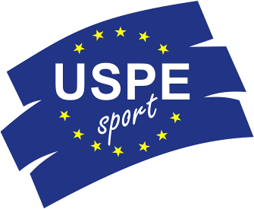 |  | 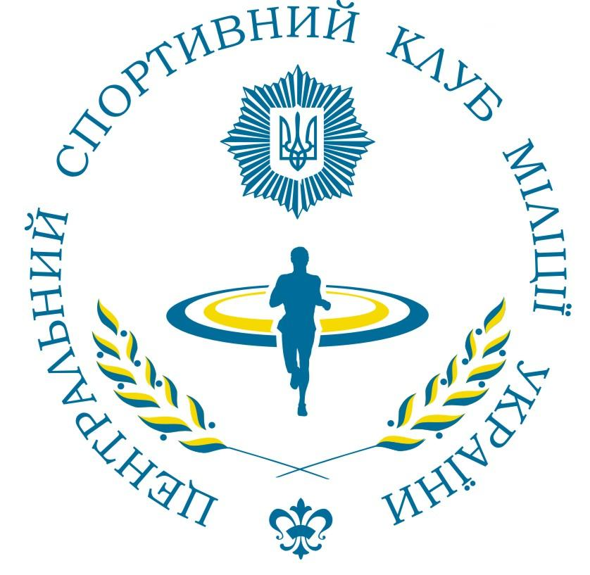
Berlin, 16.05.2013

14th USPE European Police Championships Swimming
10th – 14th of September 2013 in Dnepropetrovsk/Ukraine

Invitation to Enter

The Central Sport Club of Militia of Ukraine was entrusted by the Union Sportive des Polices d’Europe (USPE) with the organization of the 14th USPE European Police Championships Swimming from 10th – 14th of September 2013 in Dnepropetrovsk.
The following invitation to enter is issued for the USPE EPC Swimming 2013.

1. General Organiser
Union Sportive des Polices d’Europe (USPE)

2. Organiser
Central Sport Club of Militia of Ukraine

3. Date
Arrival: 10.09.2013
Departure: 14.09.2013

4. Venue
Olympic Pool of the City of Dnepropetrovsk/Ukraine
50 m pool; 8 Lanes; Wavekiller
Water temperature approx.. 27° C

5. Accommodation
Hotel accommodation for all participants will be provided in Dnepropetrovsk.

The organizer will provide the transportation from Airport (from Railway station) Dnepropetrovsk to the hotel according the travelling details of all the delegations.

6. Competition rules
The USPE Competition Rules Number 4.9 including the Annex with the rules of the combined lifesaving event will apply.

The following competitions will be held for male and female:

Combined life-saving individual competition
Combined life-saving team competition
50 m Freestyle
100 m Freestyle
400 m Freestyle
50 m Breaststroke
100 m Breaststroke
50 m Backstroke
100 m Backstroke
50 m Butterfly
100 m Butterfly
200 m Individual Medley
4 x 100 m Individual Medley Relay
4 x 100 m Freestyle Relay
4 x 50 m Freestyle Mixed Relay (2 Male/2 Female Swimmers)

Individual disciplines are recognized as EPC competitions only if competitors from at least six member unions take part.

In order to promote female sport within USPE, in individual disciplines and relays, until further notice a minimum of four female competitors of four different member unions have to take part in an EPC.

Each member association may enter up to 28 male and female competitors as well as 4 attendants.
However, the number of attendants must not exceed the number of sportsmen/-women.
Each member union may enter up to 2 male/female competitors per individual discipline with regard to both men’s and ladies’ events, while no more than 4 male/female competitors may be entered for the combined life-saving contest.
For a member union to participate in the combined life-saving team competition, a minimum number of 3 entrants for the individual competitions will be required.
The number of starts in individual disciplines including the life-saving competition is limited to three per participant. One team per relay event may be entered.

The organizer has to make sure to meet the safety requirements.
The organizer has to ensure that a medical first aid will be present at the EPC.

Unless the Competition Pool has only the possibility to start from one side from start blocks, the competition 3 x 50 m Life-Saving Relay may be canceled.
In that case, only the individual times of each life-saving competition from the best three athletes (final individual ranking) of each team will be added to have the placement of the life-saving team competition.
The 4 x 50 m Freestyle mixed relay may be held as 4 x 100 m Freestyle mixed competition.
A final decision will be made during the Technical Meeting.

7. Referees
The organiser is responsible for the referees. They should be at least of the highest national level.

8. Jury of appeal
1. Chairmen see R 19 Rules and Regulations
2. Commissioners see R 19 in connection with R 15 Rules and Regulations
3. Commissioners see R 19 in connection, with R 15 Rules and Regulations
4. Ole Jacobsen Member of the Technical Commission
5. Fred Kusserow Secretary General of the USPE

Any protest must be filed in writing in one of the three official languages of the USPE within one hour after the respective competition is over. The protest fee will total 100,00 €.

9. Eligibility to start
The provisions laid down in the Statutes, the Rules and Regulations, the Competition Rules as well as the Anti-Doping Regulations of the USPE shall apply.

Article 23 Statutes: The Competitors
(1) Participation in championships is restricted to athletes, who:

- meet the starting requirements of their international union,
- belong to a national sports organisation that is a member of the USPE,
- are police officers or
- are police students at a public police academy,
- have reached the age of 18 at the time of the championships (including preliminary rounds),
- have signed the Anti-Doping Declaration,
- and submit the USPE Declaration of Participation signed by the respective President/Secretary General to the competent member of the Technical Commission.

Article R 12/2 of the Rules and Regulations: Competitors
(1) In order to be able to take part in a European championship organised by the USPE, the members of the member unions have to fulfil the following conditions:
1. They have to satisfy the provisions set out in Article 23 of the Statutes.
2. They have to be police officers or students at a public police academy. The police are a set of all bodies and institutions in charge of maintenance of public law and order (administrative police and crime investigation departments).

(2) Military police, members of the military, members of the fire brigades and civil servants that do not belong to the police are excluded from European police championships.

Sub-paragraph 1.4 of the Competition Rules
Sportsmen and -women having participated in military championships are not eligible to enter European police championships for 12 months following these military championships.

Sub-paragraph 1.7 of the Competition Rules
Competitors suspended from sports contests by the USPE or by the respective sports association due to having violated the relevant doping regulations are not eligible to enter.

Sub-paragraph 1.8 of the Competition Rules
All teams shall wear uniform sportswear displaying the emblems of their individual member union.

10. Verification of eligibility to enter
For verifying a contestant’s eligibility to start, the production of his/her police ID, his/her passport/personal identity card as well the signed Anti-Doping-Declaration will be required.

According to the USPE Statutes all participating countries must present the USPE Declaration of Participation for each athlete who will participate, signed by the respective President or Secretary General.
Without the Declaration the participation at the USPE EPC Swimming is not possible!

The verification will be effected by the representative of the USPE Technical Commission, Mr Ole Jacobsen.

11. Anti Doping

Doping tests (urine and/or blood) will be conducted during the championships, with the current WADA list of prohibited substances being applicable. (www.wada-ama.org).
Every Competitor must sign the USPE Anti-Doping-Declaration and hand it over to the USPE Technical Delegate at the accreditation.

12. Expenses/fees

12. 1. Travelling expenses
Each member union will defray its own travelling expenses.

12. 2. Board and lodging
Delegate
The expenses incurred by the delegate (Article R 11 of the Rules and Regulations) of the respective member union will be paid by the organizer.
Team
For all participants 40,00 € per person per night are to be paid to the organizer (Article R 14/3 of the Rules and Regulations).

Guests
Should a member union intend to take guests with them to the USPE European Police Championships Swimming 2013 and should the organiser be able to provide the respective accommodation, each guest shall pay the actual costs incurred by them.

The costs for guests will be 105 Euro per person a day including breakfast. If somebody wants he can have lunch just for 15 Euro and dinner for 15 Euro too.

The respective invoices will be sent by the organizer.

12. 3. Registration fee
Article R 14/2 of the Rules and Regulations:
Prior to a championship each participating nation has to pay a registration fee to the General Treasurer of the USPE.
This fee has to be paid before the opening of the championships.

Registration fees:
Each start (single/relay): 40,00 EUR

The respective invoices will be sent to the participating member countries in time by the USPE.

13. Registration
Each participating member country is requested to send the enclosed forms

You are requested to send enclosed forms to the

Central Sport Club of Militia of Ukraine  E-Mail: cskm@mvs.gov.ua | Office of the USPE Secretary General  E–Mail: office@uspe.org

Please meet the following deadlines:
Form 2: Number of Participants 10.03.2013
Form 3: Participants Names. 30.07.2013
Form 4: Travelling Details 10.08.2013

14. Timetable

10.09.2013

Arrival, Accreditation, Training, Technical Meeting

11.09.2013

Combined Life Saving Competition Single

Women 50 m swimming, fully dressed
Men 50 m swimming, fully dressed

Women 50 m diving/swimming, combined event
Men 50 m diving/swimming, combined event

Women 50 m rescue of a dummy
Men 50 m rescue of a dummy

Combined Life Saving Relay (Necessary for the Team Score)

Women 3 x 50m Relay:
- 50 m rescue of a dummy
- 50 m lifesaving combined event
- 50 m swimming, fully dressed

Men 3 x 50m Relay
- 50 m rescue of a dummy
- 50 m lifesaving combined event
- 50 m swimming, fully dressed

12.09.2013

Morning Afternoon

Preliminary Heats: Gender: Finals:
(Only if more than 8 participants)

50 m Freestyle Women 50 m Freestyle
50 m Freestyle Men 50 m Freestyle
Medal Ceremonies
100 m Breaststroke Women 100 m Breaststroke
100 m Breaststroke Men 100m Breaststroke
Medal Ceremonies
100 m Butterfly Women 100 m Butterfly
100 m Butterfly Men 100 m Butterfly
Medal Ceremonies
50 m Backstroke Women 50 m Backstroke
50 m Backstroke Men 50 m Backstroke
Medal Ceremonies
200 m individual medley Women 200 m individual medley
200 m individual medley Men 200 m individual medley
Medal Ceremonies
4 x 100 m Freestyle Women 4 x 100 m Freestyle
4 x 100 m Freestyle Men 4 x 100 m Freestyle H
Medal Ceremonies

13.09.2013

Morning Afternoon

Preliminary Heats: Gender: Finals:
(Only if more than 8 participants)

100 m Freestyle Women 100 m Freestyle
100 m Freestyle Men 100 m Freestyle
Medal Ceremonies
50 m Breaststroke Women 50 m Breaststroke
50 m Breaststroke Men 50 m Breaststroke
Medal Ceremonies
100 m Backstroke Women 100 m Backstroke
100 m Backstroke Men 100 m Backstroke
Medal Ceremonies
50 m Butterfly Women 50 m Butterfly
50 m Butterfly Men 50 m Butterfly
Medal Ceremonies
400 m Freestyle Women 400 m Freestyle
400 m Freestyle Men 400 m Freestyle
Medal Ceremonies
4 x 100 m individual medley relay Women 4 x 100 m individual medley relay
4 x 100m individual medley relay Men 4 x 100 m individual medley relay
4 x 50 m Freestyle Mixed 4 x 50 m Freestyle
(2 F/2 M)
Medal Ceremonies at the Final Banquet

14.09.2013

Departure

15. Restriction of personality rights

Entrants consent through their entry that their personal data/information shall be recorded for the generation of entrant, competition and results’ lists in a file and shall be published on the Internet or in USPE publications.
They also consent that photographs/film recordings produced prior to, during and after the event may be used for the purpose of USPE public relations work.

16. Disclaimer

The USPE and The Central Sport Club of Militia of Ukraine shall not assume any liability in the event of accidents, theft and other events of damage or loss.
The disclaimer shall be recognised upon registration for the event.

17. Notes

One contestant per team has to wear the police uniform of their respective country at the opening ceremony.

All teams shall wear uniform sportswear displaying the emblem of their individual member union.

As to the Final Banquet, you are requested to attend adequately dressed to suit the occasion (No blue Jeans).

The participating teams are responsible for the assurance of their delegation.

Fred Kusserow Andriy Loboda
USPE Secretary General General Secretary of the Central
Sport Club of Militia of Ukraine

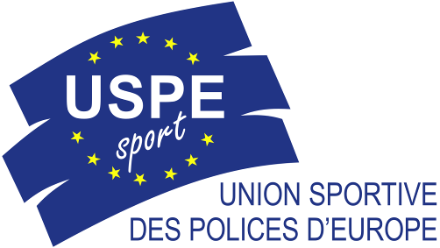 | DECLARATION OF PARTICIPATION  IN A EUROPEAN POLICE CHAMPIONSHIP (USPE)
In application of the decision adopted by the USPE Congress in Antwerp (Belgium) on 23 October 2010 and of the provisions contained in the USPE Statutes as well as the USPE Rules and Regulations,

I, the undersigned,

Last name: ………….....................................................First name: …………………………….

 President  Secretary-General

of the following association (federation ) : ...........................……………………………………………………
…………………………………………………………………………………………………..............

- hereby declare that the following competitor,

Last name: ……………………………………………...First name: …………………………….

Date of birth: ………………………Gender:  M  F Nationality: ……………..……..

complies with the following conditions of participation in a European Police Championship (CEP); he/she

- satisfies the relevant entry conditions established by the International Federation,
- belongs to a national organization that is a member of the USPE,
- is a member of the police profession and works actively in law enforcement to ensure the security of property and persons or the maintenance of public order, or, failing that, is a trainee at a police school and in line to become a member of the police profession,
- will be at least 18 years old by the first day of the European Police Championship in question,
- must sign the USPE anti-doping declaration,
- will be able to present to the USPE technical delegate a police ID as well as a further identification document, both of which are valid,
- is not a member of a military police unit, a military unit, or a firefighting unit,
- is not a member of a civilian profession,
- has not participated in a military competition in the 12 months preceding the European Police Championship,
- is not under disciplinary sanctions for violation of anti-doping rules;

- the competitor is aware that these conditions apply to the final phase just as much as they do to the preliminary phase of the European Police Championship;
- I undertake to deliver this declaration of participation or to have it delivered to the USPE technical delegate or USPE official observer during accreditation at the European Police Championship or Preliminary Round of an EPC.

Place: Date:

Seal and signature:
Anti-Doping
Declaration
I, First Name Name , herewith confirm that I know and acknowledge the USPE Anti-Doping Regulations and the WADA World Anti-Doping Code.

Doping constitutes a violation of the USPE Anti-Doping Regulations.

Violations of Anti-Doping Regulations are:

- The presence of prohibited substances, its metabolites or markers in the athlete’s bodily specimen.

  - It is each athlete’s personal duty to ensure that no prohibited substances enter his or her body. Athletes are responsible for any prohibited substance or its metabolites or markers found to be present in their bodily specimens. Accordingly, it is not necessary that intent or negligence on the athlete’s part be demonstrated in order to establish an anti-doping violation.
  - The presence of any quantity of a prohibited substance or its metabolites or markers in an athlete’s sample shall constitute an anti-doping rule violation, excepting those substances for which a quantitative reporting threshold is specifically identified in the WADA “List of Prohibited Substances and Methods”.
  - As an exception to the general rule, the „WADA List of Prohibited Substances and Methods“ may establish special criteria for the evaluation of prohibited substances that can also be produced by the body itself (endogenously).

- Use or attempted use of a prohibited substance or a prohibited method.

  - The success or failure of the use of a prohibited substance or prohibited method is not material. It is sufficient that the prohibited substance or the prohibited method was used or attempted to be used for an anti-doping rule violation to be committed.
  - Refusing, or failing without compelling justification, to submit to sample collection after notification as authorised in the USPE regulations or any other anti-doping regulations, or otherwise attempting to willingly evade sample collection.
  - Tampering or attempting to tamper with any part of doping control.

- Possession of prohibited substances and prohibited methods.

  - Possession by an athlete
Possession by an athlete at any time or place of substances that are prohibited in out-of-competition testing in accordance with the WADA Prohibited List or the use of prohibited methods by an athlete, unless the athlete establishes that the possession is pursuant to a Therapeutic Use Exemption (TUE) granted or other acceptable justification.
  - Possession by athlete support personnel
Possession by athlete support personnel of substances that are prohibited in out-of-competition testing in accordance with the WADA Prohibited List or the use of prohibited methods by athlete support personnel (in particular doctors, trainers/coaches , attendants and support staff) in connection with an athlete, competition or training, unless the athlete support personnel establishes that the possession is pursuant to a Therapeutic Use Exemption (TUE) granted to the athlete or other acceptable justification.

- Trafficking in any prohibited substance or prohibited method.

- Administration or attempted administration of prohibited substances or prohibited methods to any athlete or assisting, encouraging, aiding, abetting, covering up or any other type of complicity involving an anti-doping violation or any attempted violation of the anti-doping regulations.

- Participation or attempted participation in European Police Championships during a period of suspension or ineligibility imposed by the USPE or any other international or national sports federations.

The undersigned accepts full personal responsibility for compliance with the above set of rules. He/she accepts that any violation of these regulations will give rise to sanctions, in particular with regard to cost of proceedings and the respective measures governed by the applicable national provisions of the member countries.

______________________________ _____________________________
Venue, date Signature Athlete, Attendant, Delegate

